**Task -1: Write a python program to find the largest of three numbers.**

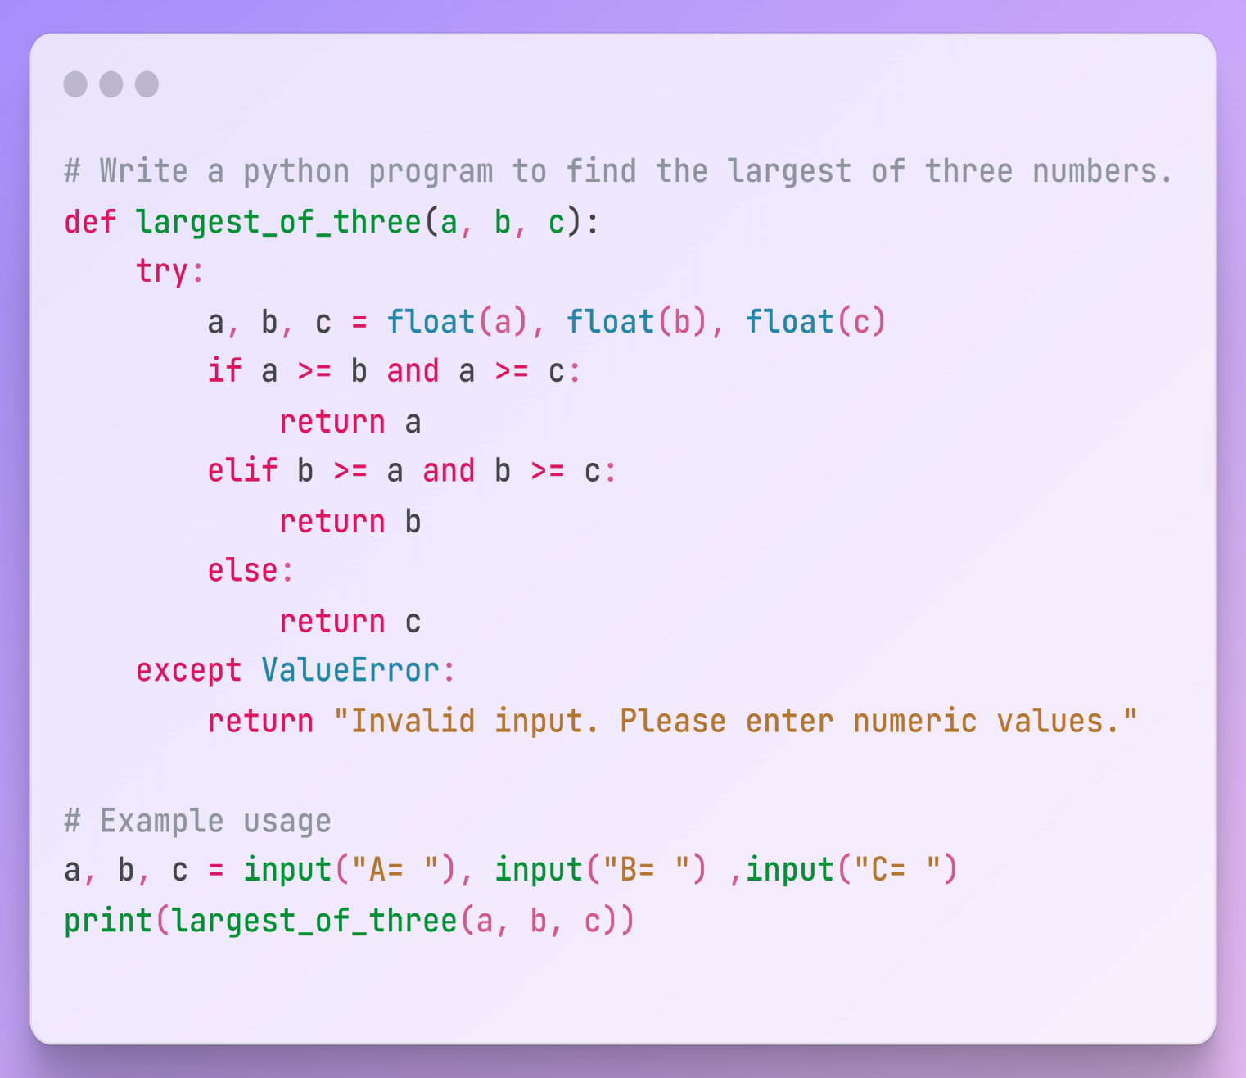

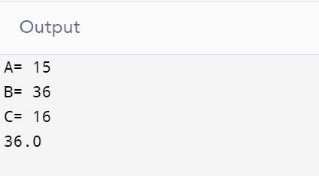

**Task-2: Write a program to calculate area of triangle.**

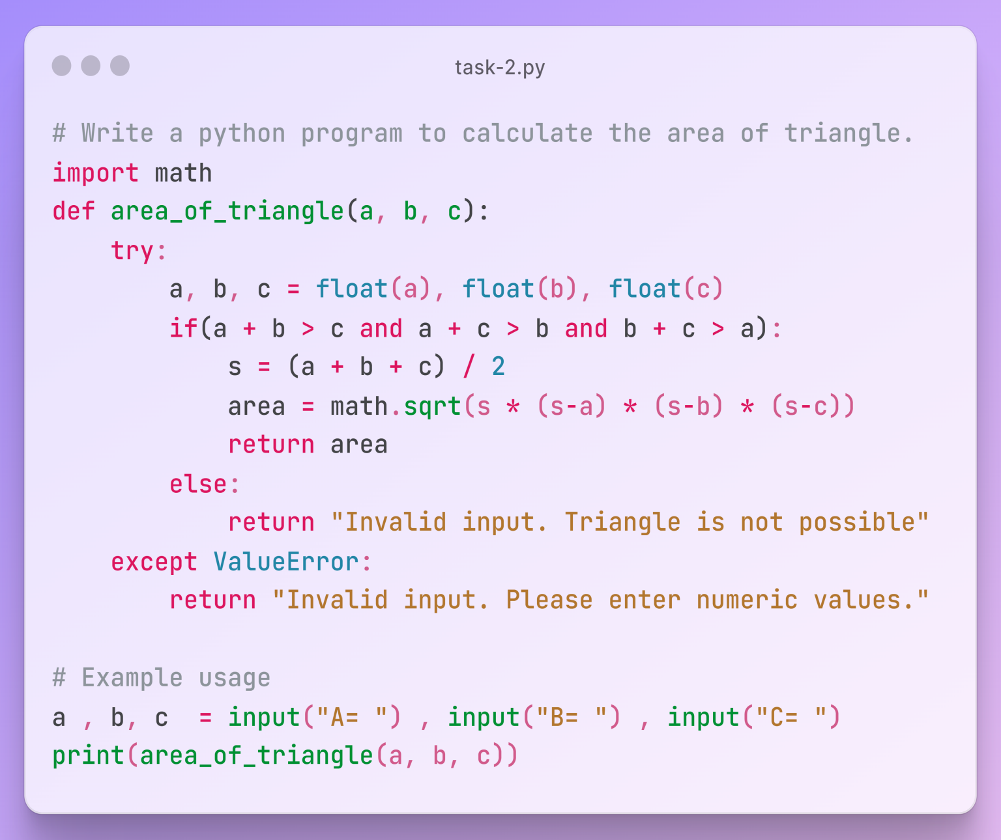

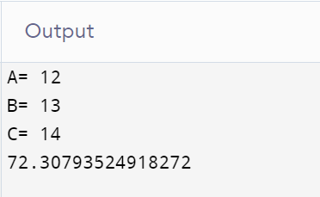

**Task-3: Write a python program to find even numbers from 1 to 200 using function.**

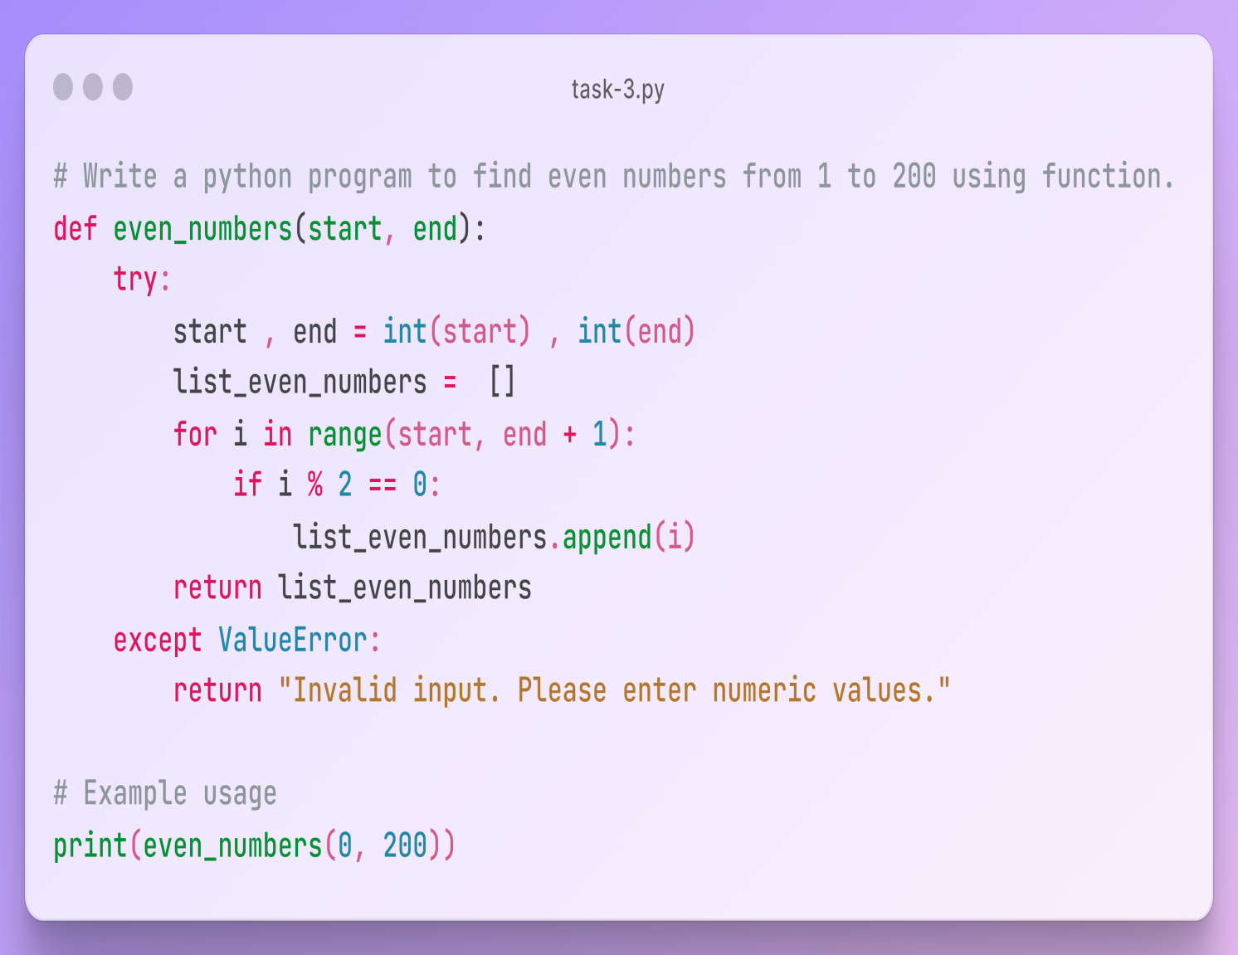

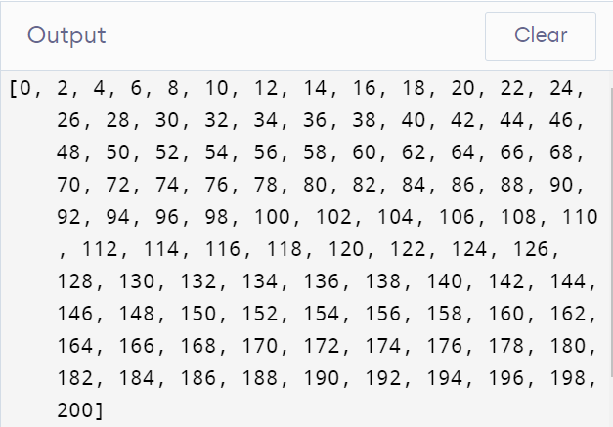

**Task-4: Write a python program to find the area of circle and area of rectangle using function.**

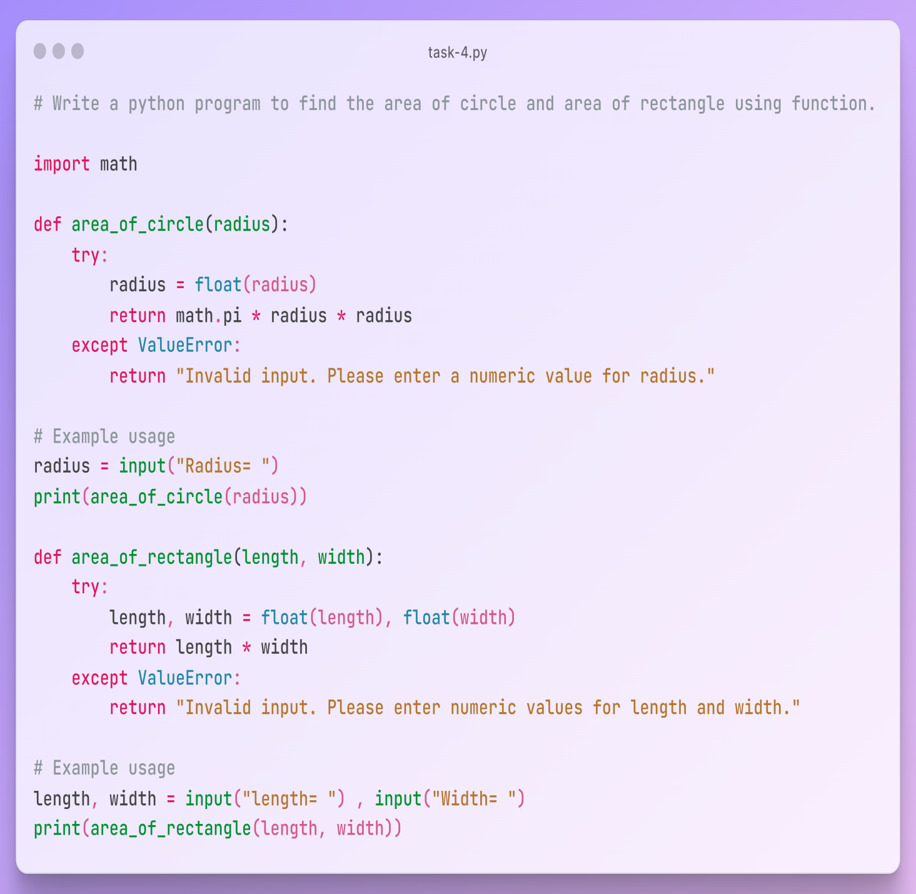

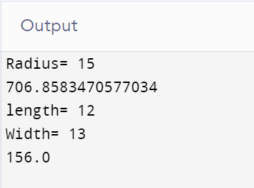

**Task-5: Write a python program to find out which word is vowel or consonant using function.**

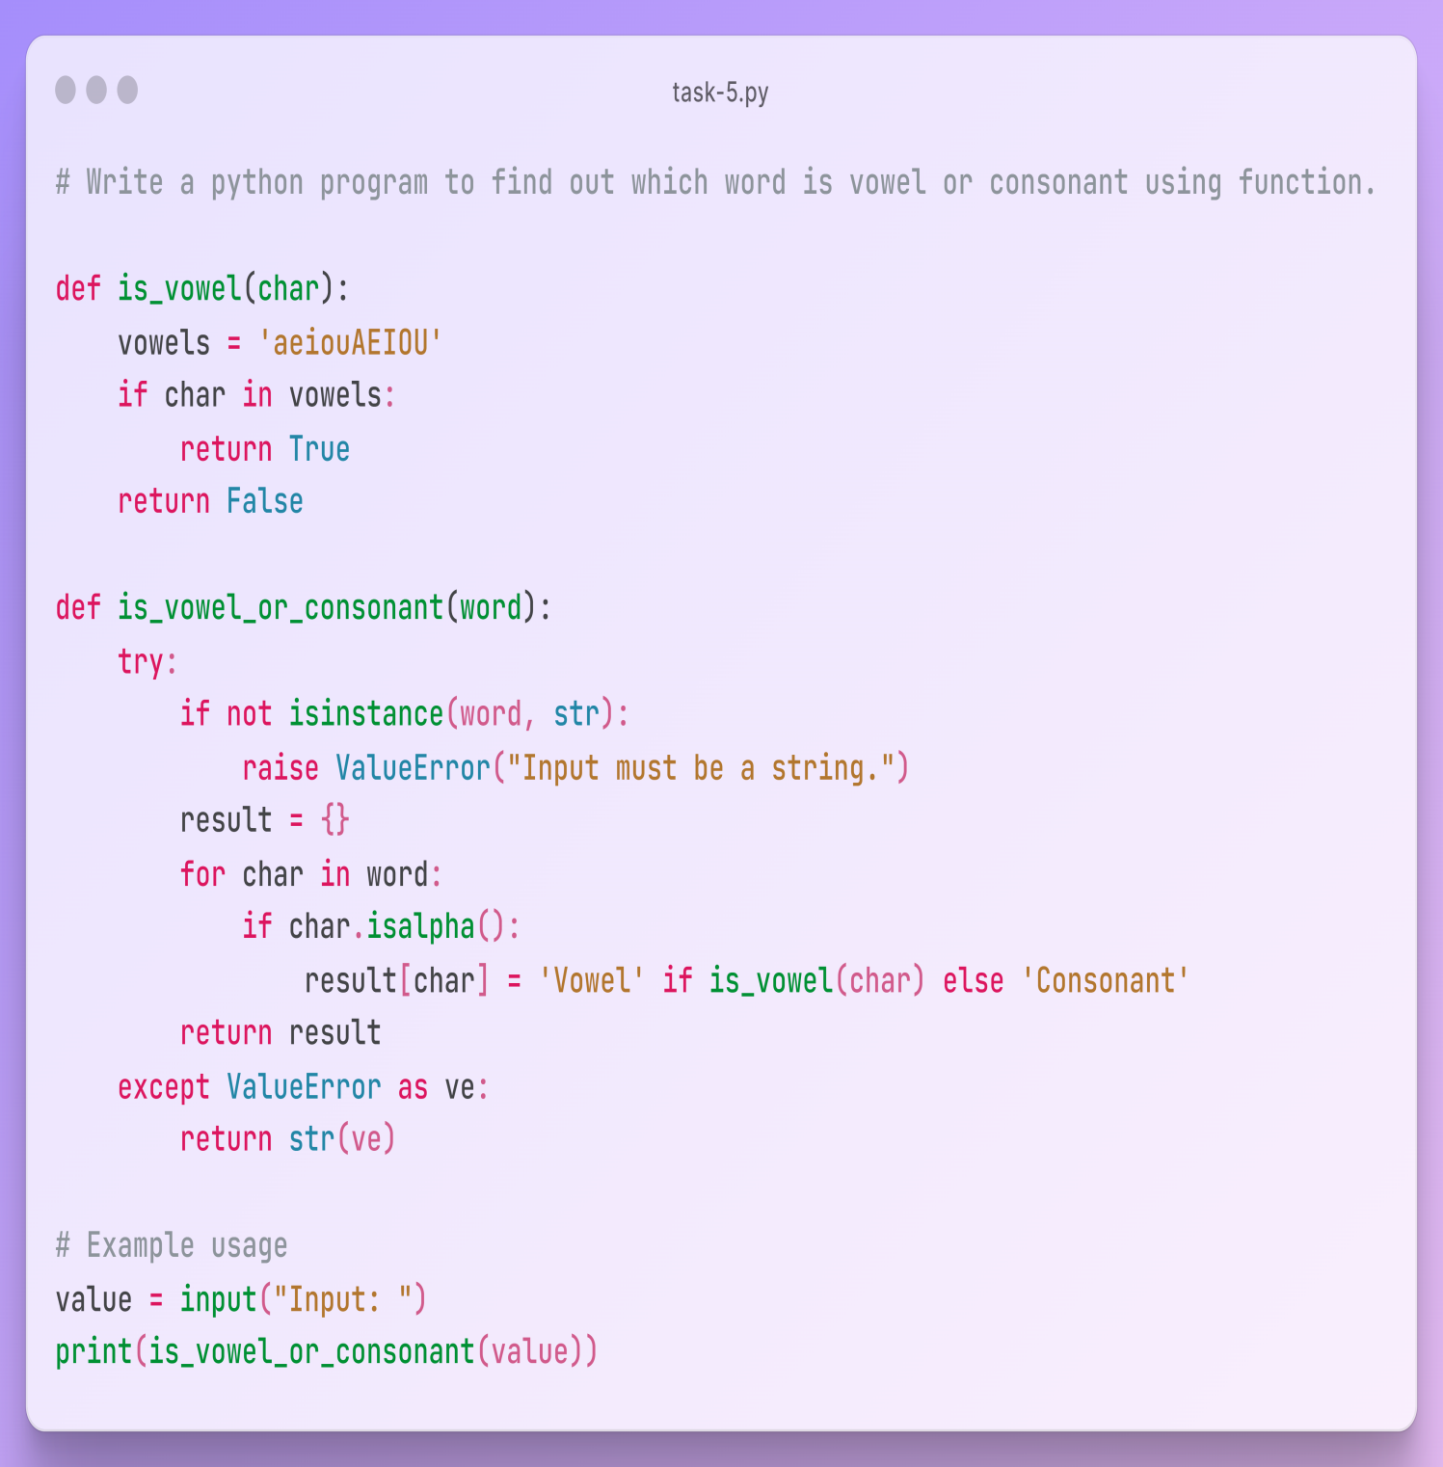

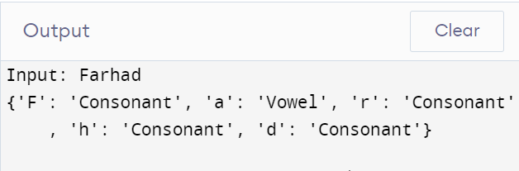

**Task-6: Write a python program to find grade of a student in diploma Curriculum.**

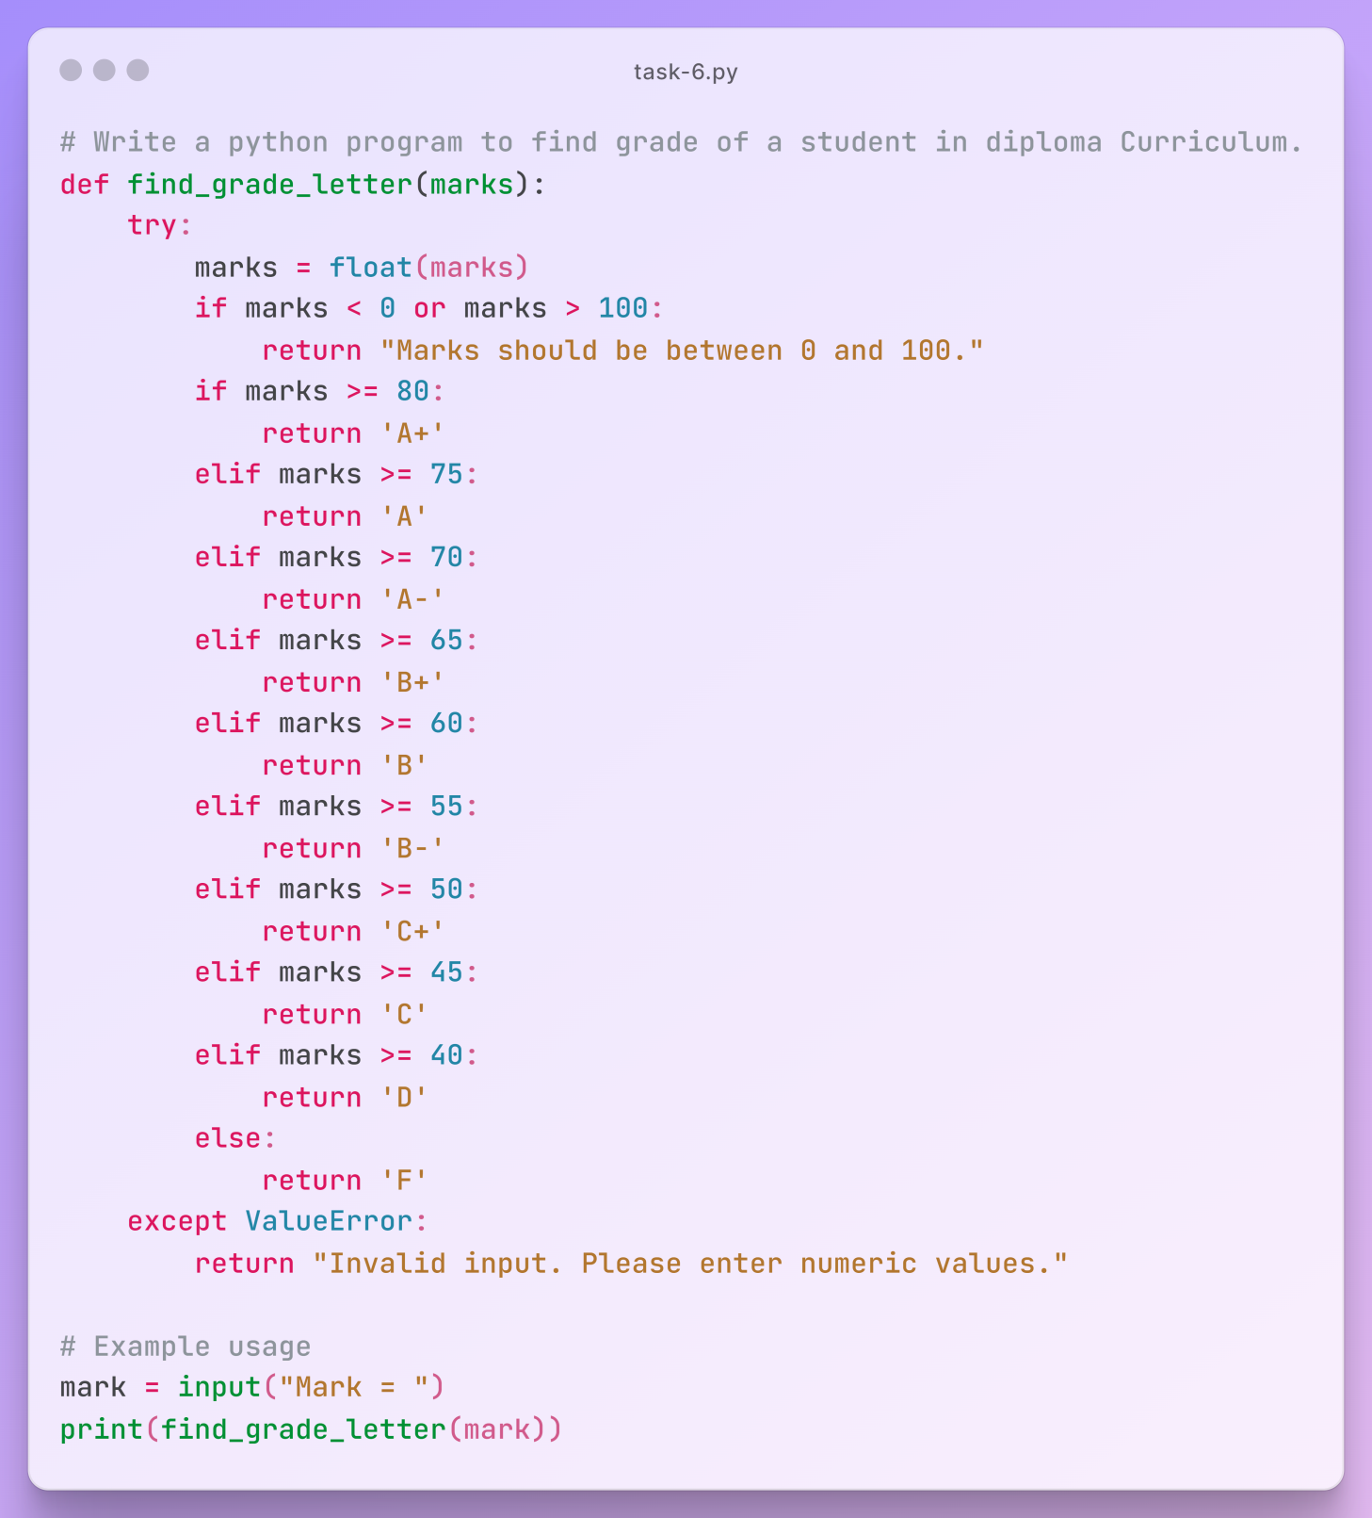

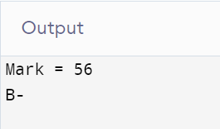

**Task-7: Write a python program to find the factorial of a number using function.**

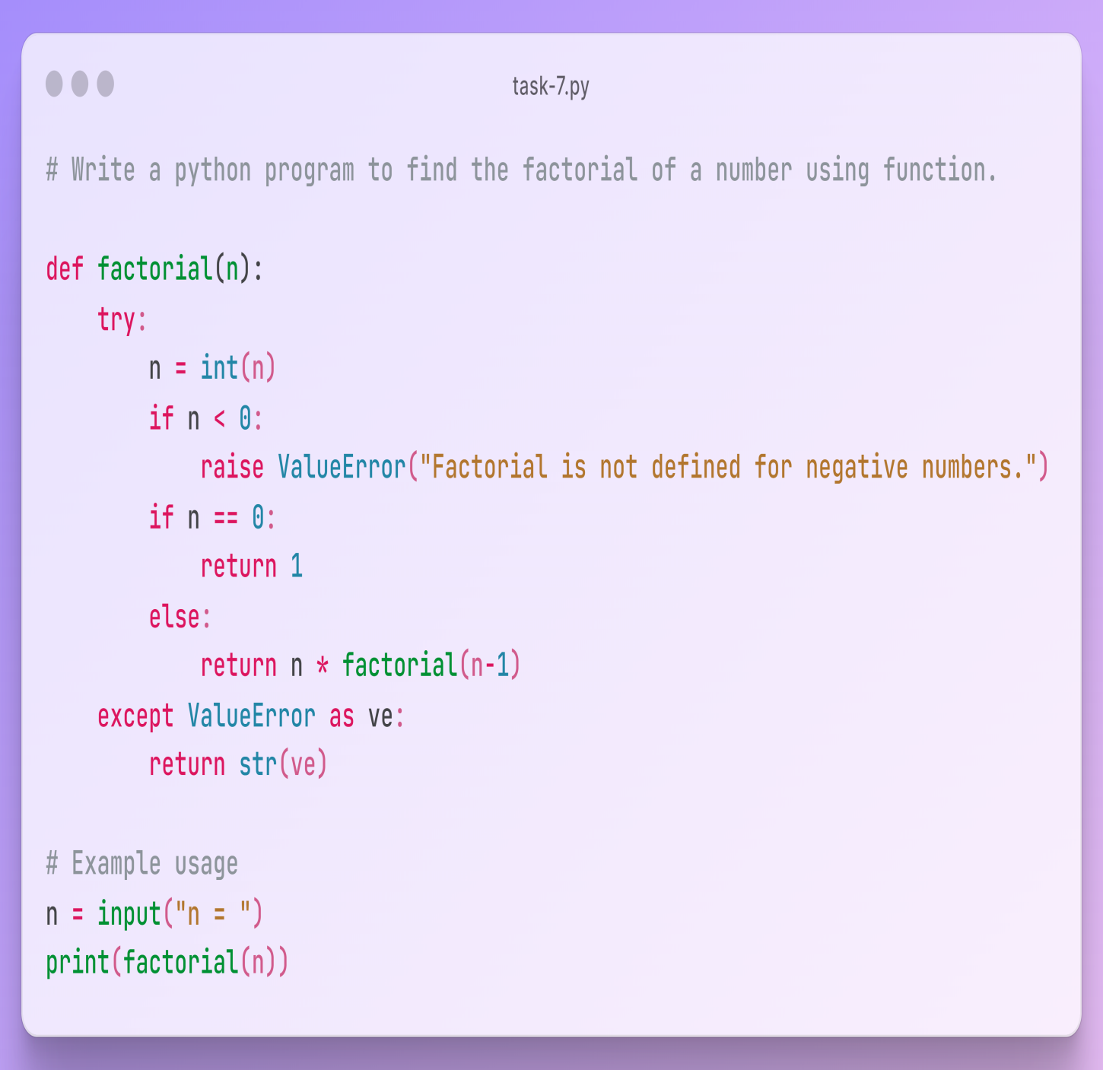

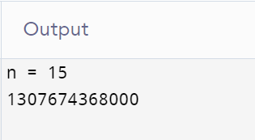

**Task-8: Write a python program to display the multiplication table.**

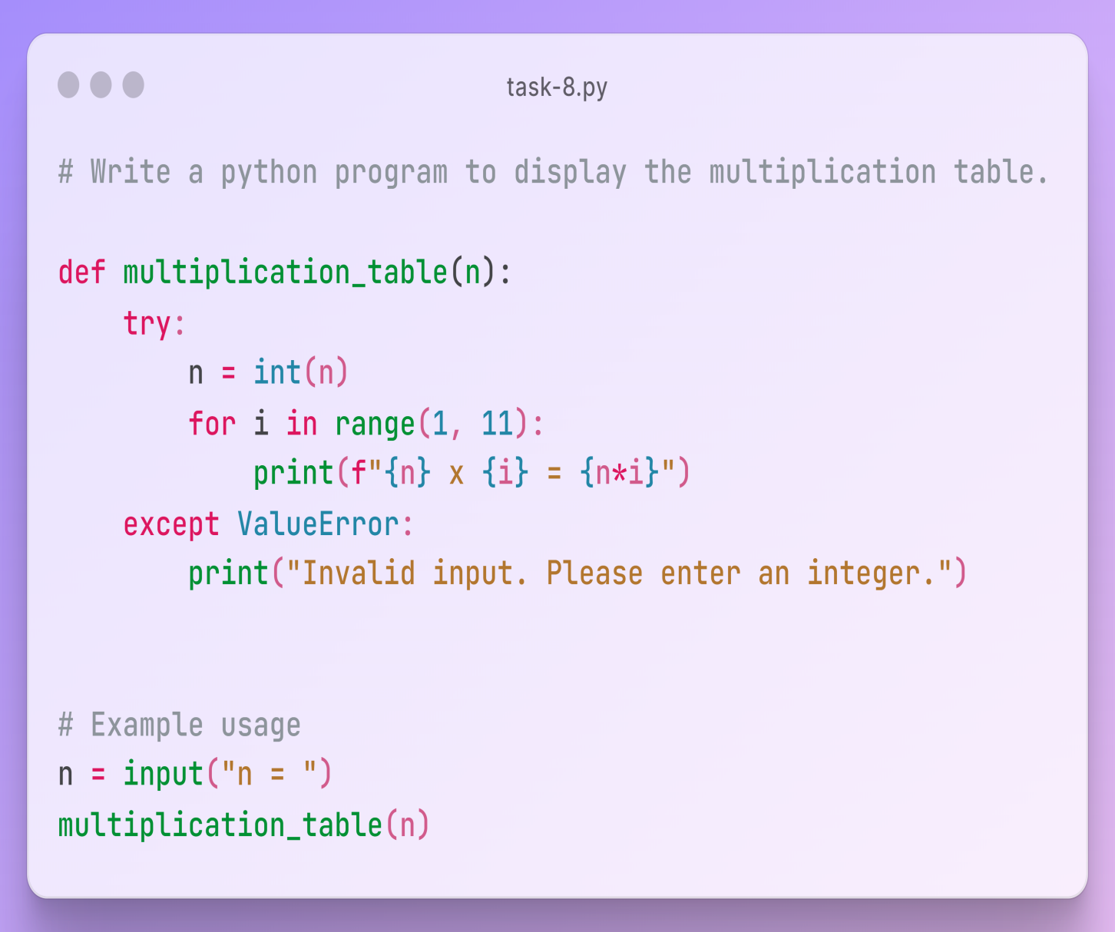

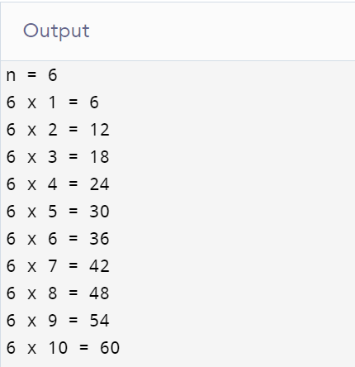

**Task-9: Write a python function that takes a number as input and returns whether it's a prime number or not.**

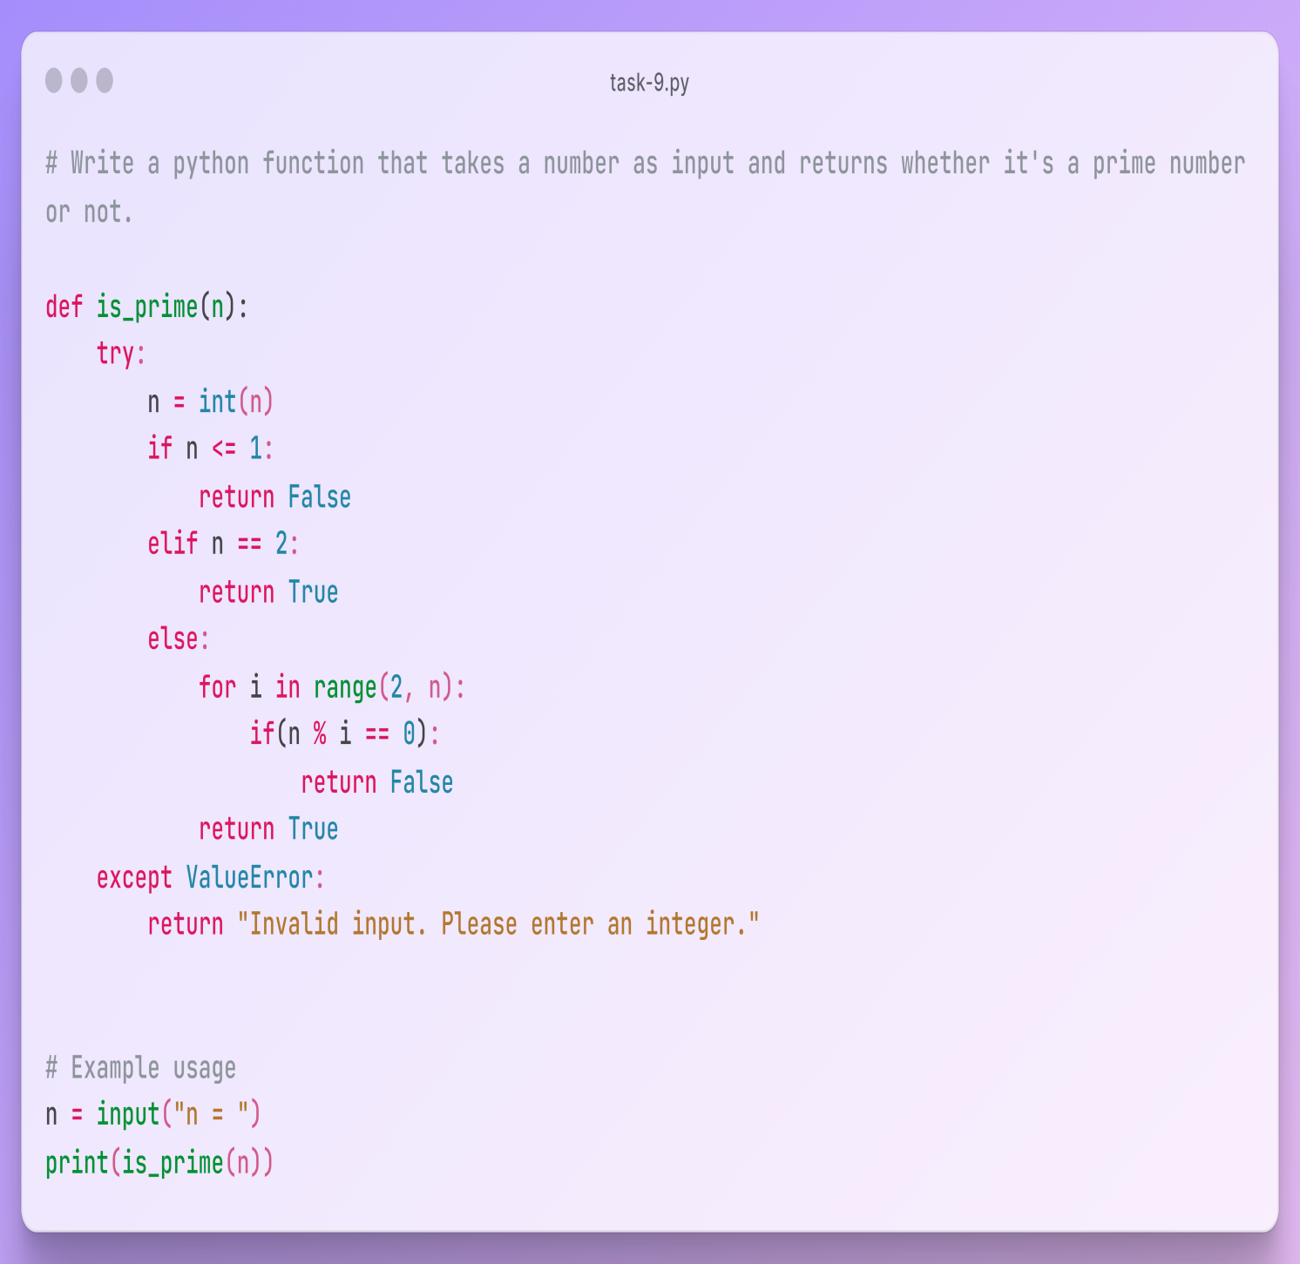

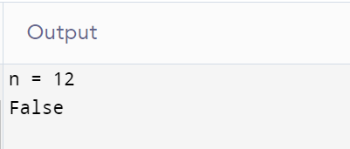

**Task-10: Write python program to swap two numbers using function.**

